SNo | Name | Name of KV | Achievement | Photo
1 | Raj Vijay | No.2 Tambaram , Chennai | KVS Topper - 1st Position in AISSCE (Science Stream) - 2016  Marks : 494/500(98.8%) | 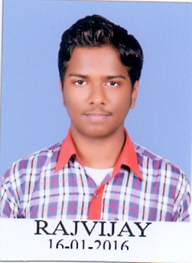
2 | S. Mahima | No.2 Kalpakkam , TN | KVS Topper - 3rd Position in AISSCE (Science Stream) - 2016  Marks : 489/500(97.8%) | 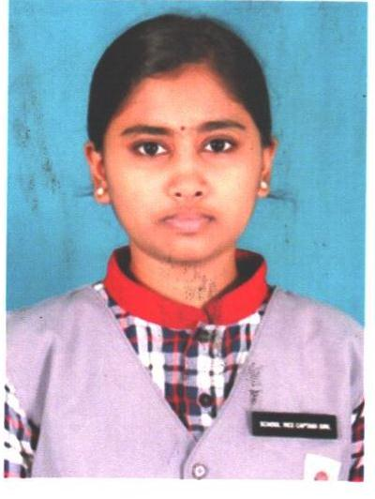
3 | M. Indumathi | No.1 Madurai , TN | KVS Topper - 4th Position in AISSCE (Commerce Stream) - 2016  Marks : 485/500(97%) | 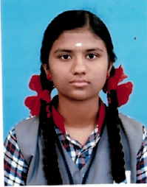
4 | G. Siddharthan | No.1 Tammbaram , Chennai. | KVS Topper - 2nd Position in AISSCE (Humanities Stream) - 2016  Marks : 484/500(96.8%)
5 | V. Madhismitha | DGQA , Chennai. | KVS Topper - 3rd Position in AISSCE (Humanities Stream) - 2016  Marks : 482/500(96.4%) | 